EXPERIMENT NO. 6 - (DML COMMANDS)

AIM:

* Insert 5 instances into the tables created in experiment 6.
* Display the tables.
* Add attribute course to student table then insert values.
* Use update to set course for students.
* Delete an attribute.

SOLUTION:

**Components:**

1. DML (Data Manipulation Language):The SQL commands that deals with the manipulation of data present in the database belong to DML or Data Manipulation Language and this includes most of the SQL statements.

Examples of DML:

* + [INSERT](https://www.geeksforgeeks.org/sql-insert-statement/) – is used to insert data into a table.
  + [UPDATE](https://www.geeksforgeeks.org/sql-update-statement/) – is used to update existing data within a table.
  + [DELETE](https://www.geeksforgeeks.org/sql-delete-statement/) – is used to delete records from a database table.

Code:

Insert into student values (1,'Varshitha', 'female','maths',98,'A','Khammam');

Insert into student values (2, 'Swapna', 'female', 'maths',90,'A','Khammam');

Insert into student values (3,'Yoshitha', 'female', 'maths',85,'B','Hyderabad');

Insert into student values (4,'pravalika','female', ‘maths',80,'A','kammareddy');

Insert into student values (5,'chaitu','male', 'maths',89,'A','Vizag');

Insert into student values (6, 'varun','male','maths',90, 'A', ' Hyderabad');

Insert into faculty values (1,'Varshitha','dbms', 98,'very good');

Insert into faculty values (2, 'Swapna','dbms',90, 'very good');

Insert into faculty values (3,'Yoshitha','dbms', 85,'good');

Insert into faculty values (4,'pravalika','dbms', 80,'good');

Insert into faculty values (5,'chaitu','dbms',89,'good');

Insert into faculty values (6,'varun','dbms' ,90,'very good');

Insert into department values (1,'Varshitha', 'A','Hardworking',98);

Insert into department values (2, 'Swapna', 'A','multitalent',90);

Insert into department values (3,'Yoshitha', 'B','hardworking',80);

Insert into department values (4,'pravalika','A','creative',90);

Insert into department values (5,'chaitu','A','communication',90);

Insert into department values (6,'varun','A','problem solving skills','80','Khammam');

Insert into activity values (1,'varshitha','hardworking','c','chaitanya');

Insert into activity values (2,'swapna','multitalented','c++','laxmi');

Insert into activity values (3,'yoshitha','hardworking','python','kamala');

Insert into activity values (4,'pravalika','creative','dbms','saritha');

Insert into activity values (5,'chaitu','hardworking','os','veerababu');

Insert into activity values (6,'varun','problem solving skills','java','supriya');

select *from faculty;

select *from department;

select *from activity;

Alter table College.student add (course varchar (50));

UPDATE College.student SET course = 'c' WHERE stdid=1;

UPDATE College.student SET course = 'python' WHERE stdid=3;

UPDATE College.student SET course = 'c++' WHERE stdid=2;

UPDATE College.student SET course = 'dbms' WHERE stdid=4;

UPDATE College.student SET course = 'java' WHERE stdid=5;

UPDATE College.student SET course = 'os' WHERE stdid=6;

Alter table College.stuent drop column gender;

select *from student;

OUTPUT:

select *from student;

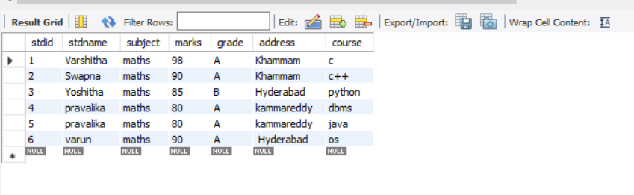

select *from faculty;

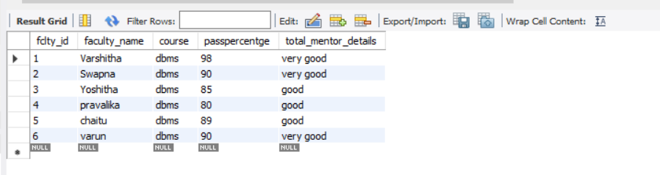

select *from department;

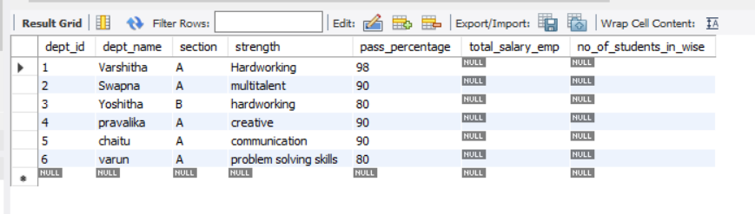

select *from activity;

